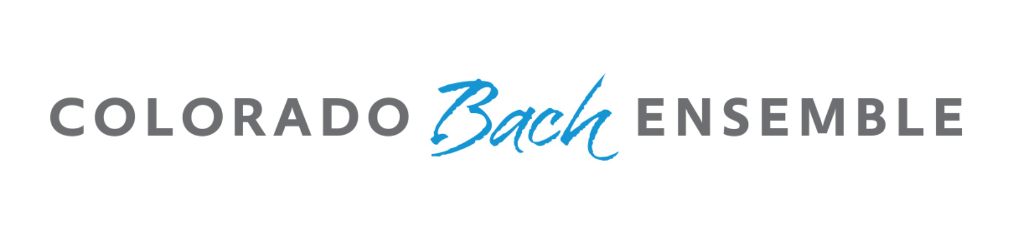

2025-2026 Competition Application Form

Upload this completed form to a Google Drive Folder, along with: a recommendation from a teacher/professional familiar with your work, a copy of identification (driver’s license or passport), a resumé and/or brief biography (up to 250 words), video files of your audition, and a headshot in .jpeg form. After you’ve uploaded all materials to a Google Drive Folder, share the folder with cbecompetition@gmail.com. Make sure that permissions are set to allow other people to edit the folder. Lastly, pay the application fee of $85.00 HERE. Click the button, enter in $85.00, and pay by PayPal transfer or credit/debit card. After sharing the google file and submitting payment, please email cbecompetition@gmail.com to confirm your submission. More important information can be found at ColoradoBach.org/competition.

The deadline to submit all materials and pay registration: Sunday, February 15, 2026 at Midnight MST (Mountain Standard Time).

First and Last Name: ________________________________________________________________________________

Address: ________________________________________________________________________________

City: _____________________________________ State: __________________________________

Zip/Postal Code: ______________________________ Country: _____________________________

Phone Number: __________________________________________

Email Address: _______________________________________________________

Preliminary Round: Recitative and Aria (please include the name of each, the work(s) they come from, and the BWV number(s), and second song/aria selection (include the name of song, the larger work it comes from if applicable, and composer)

________________________________________________________________________________

________________________________________________________________________________

* Entry in this competition constitutes your authorization to use your name, photograph, preliminary video submission, and/or biographical information for publicity purposes on our website, through email, on our YouTube channel, and other social media outlets. Signature:

____________________________________________________ Date: _______________________

